**DAILY ONLINE ACTIVITIES SUMMARY**

|  |  |  |  |  |  |  |  |  |
| --- | --- | --- | --- | --- | --- | --- | --- | --- |
| **Date:** | **29-06-2020** | | | | | **Name:** | **Anix Jugal D’Cunha** | |
| **Sem & Sec** | **8 sem , A sec** | | | | | **USN:** | **4AL16CS013** | |
| **Online Test Summary** | | | | | | | | |
| **Subject** | | **SMS** | | | | | | |
| **Max. Marks** | | **60** | | **Score** | | | **Marks not emailed by techgig** | |
| **Certification Course Summary** | | | | | | | | |
| **Course** | **Composer - The Ultimate Guide for PHP Dependency Management** | | | | | | | |
| **Certificate Provider** | | | **Udemy** | | **Duration** | | | 2.5 hours |
| **Coding Challenges** | | | | | | | | |
| **Problem Statement:** Java program for bubble sort in Ascending & descending order | | | | | | | | |
| **Status: Competed** | | | | | | | | |
| **Uploaded the report in Github** | | | | | **yes** | | | |
| **If yes Repository name** | | | | | **alvas-education-foundation/dcunhaanixjugal** | | | |
| **Uploaded the report in slack** | | | | | **yes** | | | |

Online Test Details: (Attach the snapshot and briefly write the report for the same)

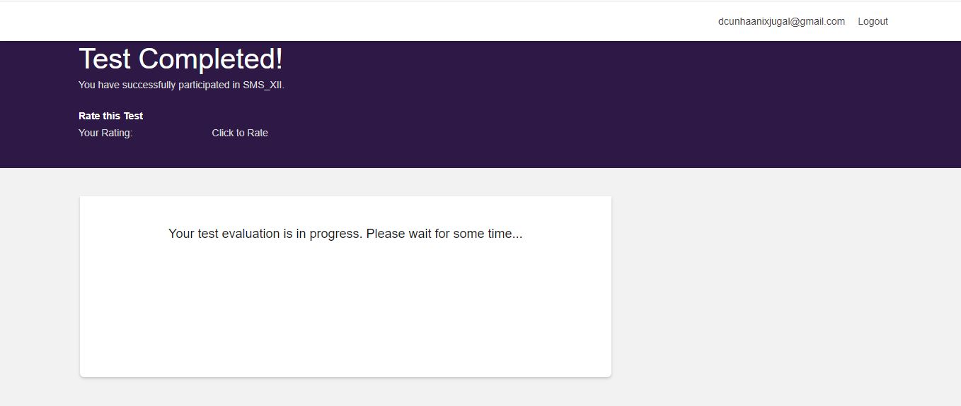

Certification Course Details: (Attach the snapshot and briefly write the report for the same)

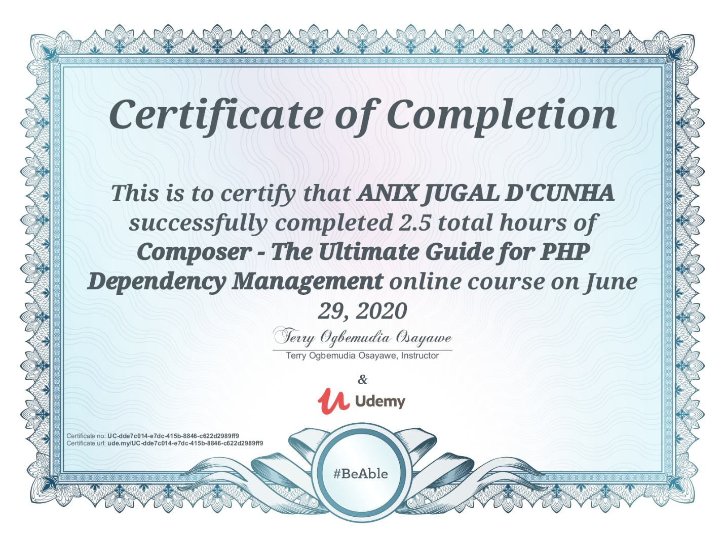

Coding Challenges Details: (Attach the snapshot and briefly write the report for the same)

## Program-> ****Java program for bubble sort in Ascending & descending order****

|  |
| --- |
| import java.util.Scanner; |
|  |  |
|  | class BubbleSortExample { |
|  | public static void main(String []args) { |
|  | int num, i, j, temp; |
|  | Scanner input = new Scanner(System.in); |
|  |  |
|  | System.out.println("Enter the number of integers to sort:"); |
|  | num = input.nextInt(); |
|  |  |
|  | int array[] = new int[num]; |
|  |  |
|  | System.out.println("Enter " + num + " integers: "); |
|  |  |
|  | for (i = 0; i < num; i++) |
|  | array[i] = input.nextInt(); |
|  |  |
|  | for (i = 0; i < ( num - 1 ); i++) { |
|  | for (j = 0; j < num - i - 1; j++) { |
|  | if (array[j] > array[j+1]) |
|  | { |
|  | temp = array[j]; |
|  | array[j] = array[j+1]; |
|  | array[j+1] = temp; |
|  | } |
|  | } |
|  | } |
|  |  |
|  | System.out.println("Sorted list of integers:"); |
|  |  |
|  | for (i = 0; i < num; i++) |
|  | System.out.println(array[i]); |
|  | } |
|  | } |